Exception Handling
________________________________________________________________________________
Q. What is Exception?
________________________________________________________________________
Exception is an event which occurs at program run time and which responsible for disturb the normal flow of application called as exceptions.

Q. What is purpose of exception handling or why use exception handling?
____________________________________________________________________________
1. It helps developer to detect the run time error
2. Avoid application crash means developer can skip the code in which exception may be occur and execution remaining application in safe zone
3. Developer can Generate the user exception means can generate the user defined error for end users as the requirement of application

If we want to work with exceptions in java we have three types of exceptions
1. Checked exception: Checked Exception means those exception occur at program compile time called as checked exceptions.
Note: checked exception known as warning exception which indicate what kind of exception may be occur probably in future so better way as precaution we can manage it at compile time

2. Unchecked Exception: Unchecked exception means those exception occur at program run time called as unchecked exception

3. Error: Error means those exceptions not handle by programmer called as error.
Q. what is difference between exception and error?
_____________________________________________________________________________
Exception may be handling by programmer at program compile time or may be at run time but error is part of exception but not handle by programmer called as error.
If we want to work with Exception in Java We have some inbuilt classes provided by java to us.

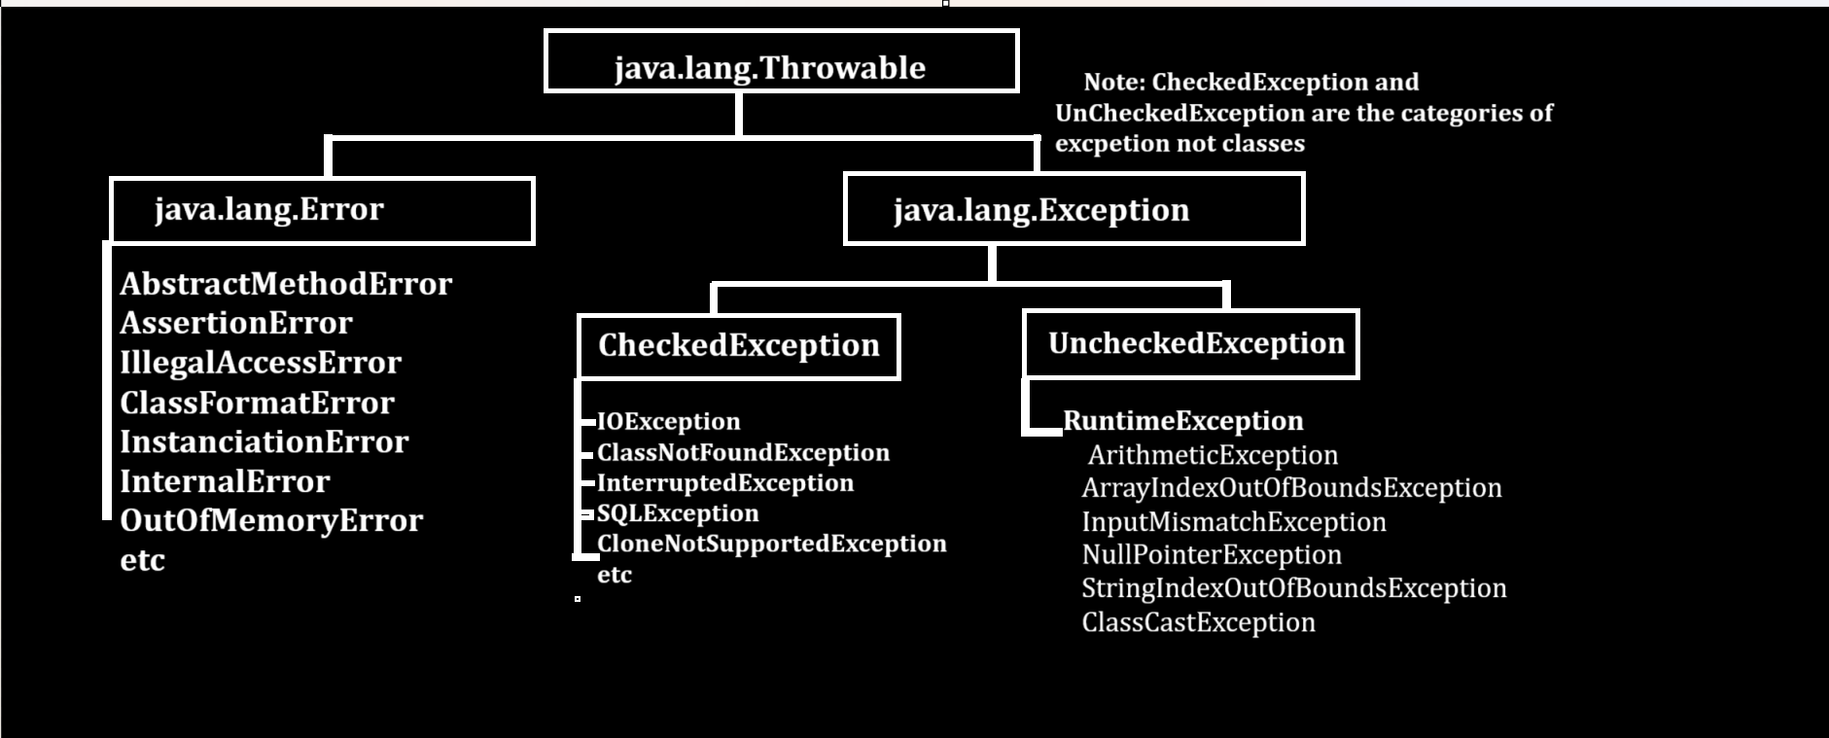
If we want to works with exception in java we have some block which help us to work with exception handling

1. try: try is block in java which is used for write the code in which exception may be occur
If exception generate in try block then JVM create one error object and hand over to catch for further executions.
2. catch : catch is block in java which always execute if exception generate in try block means we can use catch for following purpose.
a) Execute logic which wants to after exception
b) Show the error messages after exception means to detect error
Note: if exception rise in try block then catch get executed otherwise not.
How to write try and catch practically
___________________________________________________________________
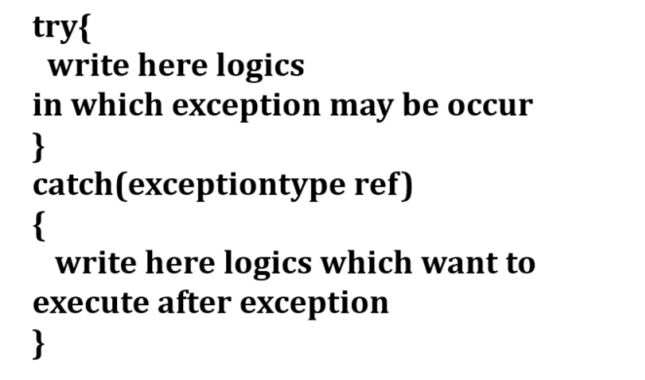
Note: we can write more than one catch block for single try
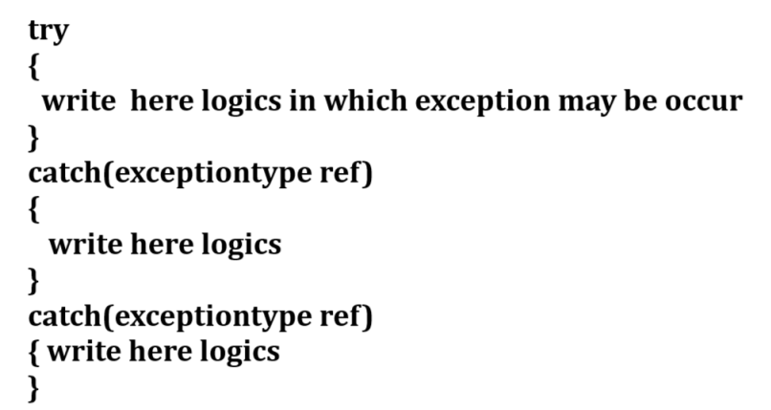

3. finally: finally block is block in java which execute if exception generate in code or not

Syntax of finally block
________________________________________________________________
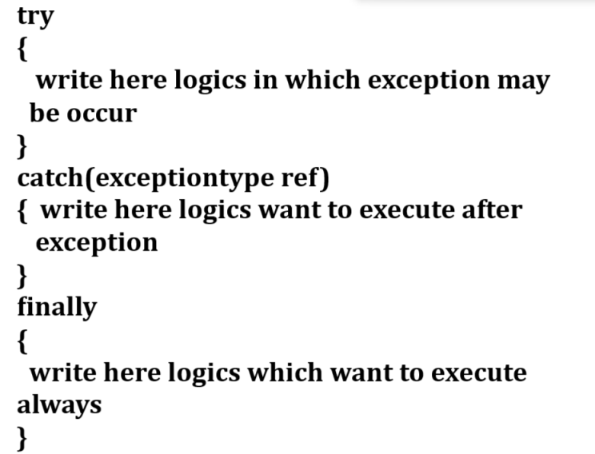
Note: we can write the finally directly with try block.
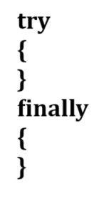
Q. Can we write try without catch block?
___________________________________________________________________
Yes we can write try without catch block because of finally means we can use finally directly with try block.
4. throw: throw is clause in exception handling which we can use the function definition and generally it is used for handle the user defines exceptions
5. throws: throws is also clause in exception handling which we can use with function definition and generally it is used for handle the checked exceptions.

Now we want to discuss about try and catch practically with some exception examples

Example of ArithmeticException
____________________________________________________________________

ArithmeticException: this is the inbuilt class present in java.lang package which is used for
or which help us to handle the ArithmeticException or Arithmetic related problem
like as divide by zero etc

Show in following code and diagram.
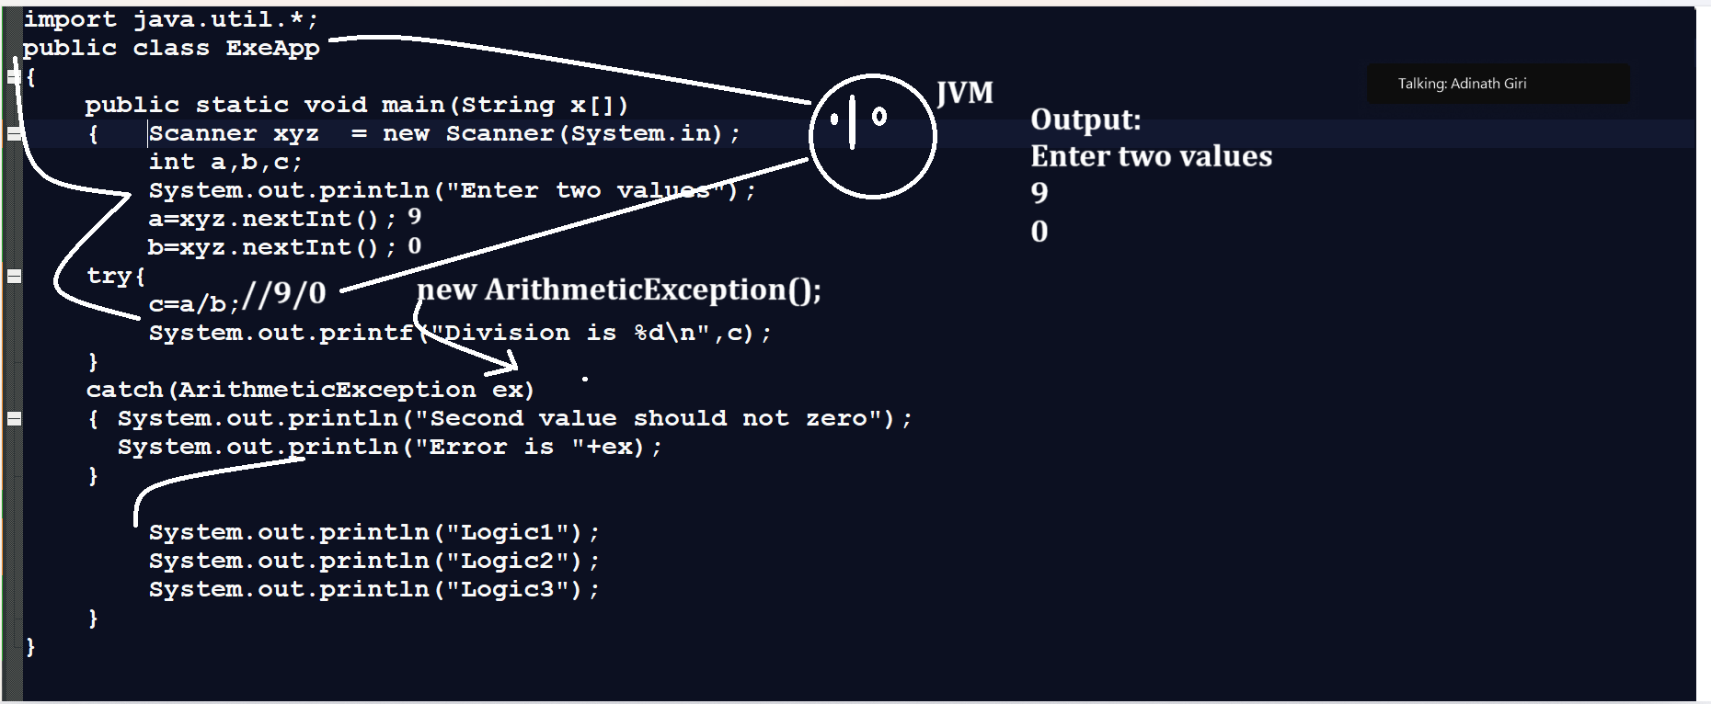

Example with source code
import java.util.*;
public class ExeApp
{
public static void main(String x[])
{ Scanner xyz = new Scanner(System.in);
int a,b,c;
System.out.println("Enter two values");
a=xyz.nextInt();
b=xyz.nextInt();
try{
c=a/b;
System.out.printf("Division is %d\n",c);
}
catch(ArithmeticException ex)
{ System.out.println("Second value should not zero");
System.out.println("Error is "+ex);
} System.out.println("Logic1");
System.out.println("Logic2");
System.out.println("Logic3");
}
}

NumberFormatException
__________________________________________________________________________
NumberFormatException occur when we want to perform conversion between string to number
when we perform conversion between string to number and if any non numeric character present in string then we get run time exception called as NumberFormatException.

Example with source code
public class NumFormApp
{ public static void main(String x[])
{
try{
String s="12345 ";
int a=Integer.parseInt(s);
System.out.printf("A =%d\n",a);
}
catch(NumberFormatException ex)
{ System.out.println("Plase check string string data");
System.out.println("Error is "+ex);
}
System.out.println("Logic1");
System.out.println("Logic2");
}
}
ArrayIndexOutOfBoundsException: These exceptions occur when user try to access the value from array beyond its size or index value is greater than size of array.
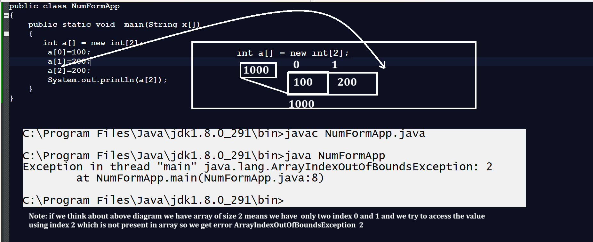

Example with source code
public class NumFormApp
{
public static void main(String x[])
{
try
{ int a[] = new int[2];
a[0]=100;
a[1]=200;
a[2]=200;
System.out.println(a[2]);
}
catch(ArrayIndexOutOfBoundsException ex)
{ System.out.println("error is "+ex);
}
}
}

NullPointerException
_________________________________________________________________________
NullPointerException occur when use any reference without memory allocation or without new keyword then NullPointerException get occur.
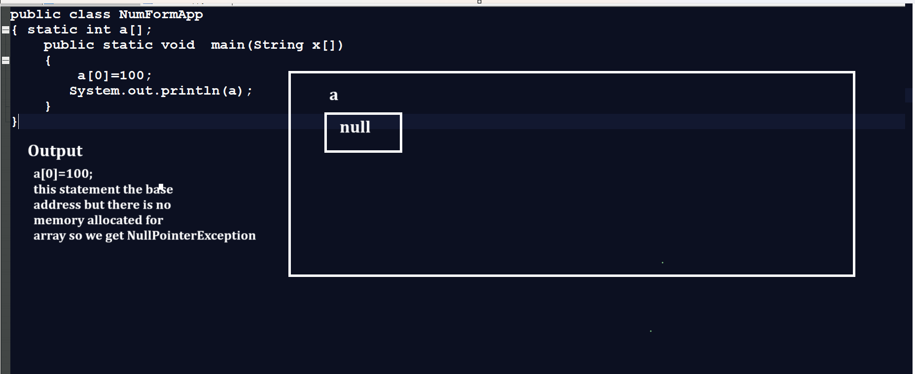

So if we want to handle this exception at program run time then we have NullPointerException class provided by java.lang package in application.

Example with source code
public class NumFormApp
{ static int a[];
public static void main(String x[])
{
try
{ a[0]=100;
System.out.println(a);
}
catch(NullPointerException ex)
{ System.out.println("error is "+ex);
}
}
}
NegativeArraySizeException: This exception occur at program run time when user try to set array size as neagive.
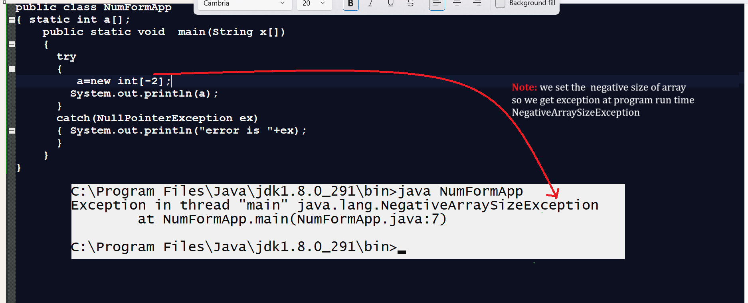
Note: You can handle the above exception like as
public class NumFormApp
{ static int a[];
public static void main(String x[])
{
try
{ a=new int[-2];
System.out.println(a);
}
catch(NullPointerException ex)
{ System.out.println("error is "+ex);
}
catch(NegativeArraySizeException ex)
{ System.out.println("Error is "+ex);
}
}
}
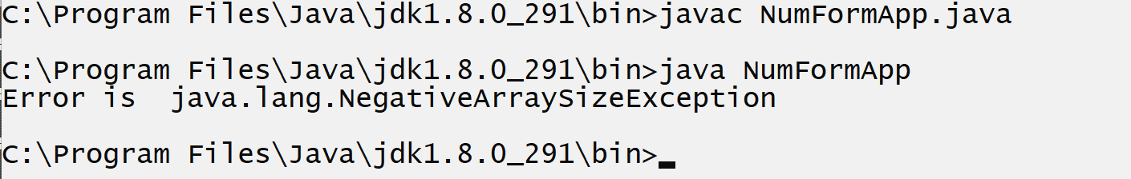

InputMismatchException
__________________________________________________________________
This class help us to handle the exception InputMismatchException at program run time
import java.util.*;
public class NumFormApp
{
public static void main(String x[])
{
try
{int a,b;
Scanner xyz = new Scanner(System.in);
System.out.println("Enter two values");
a=xyz.nextInt();
b=xyz.nextInt();
System.out.println("Division is "+(a/b));

}
catch(NullPointerException ex)
{ System.out.println("error is "+ex);
}
catch(NegativeArraySizeException ex)
{ System.out.println("Error is "+ex);
}
catch(InputMismatchException ex)
{ System.out.println("Error is "+ex);
}
}
}

Note: you can handle any JSE exception by using single class name as Exception class.
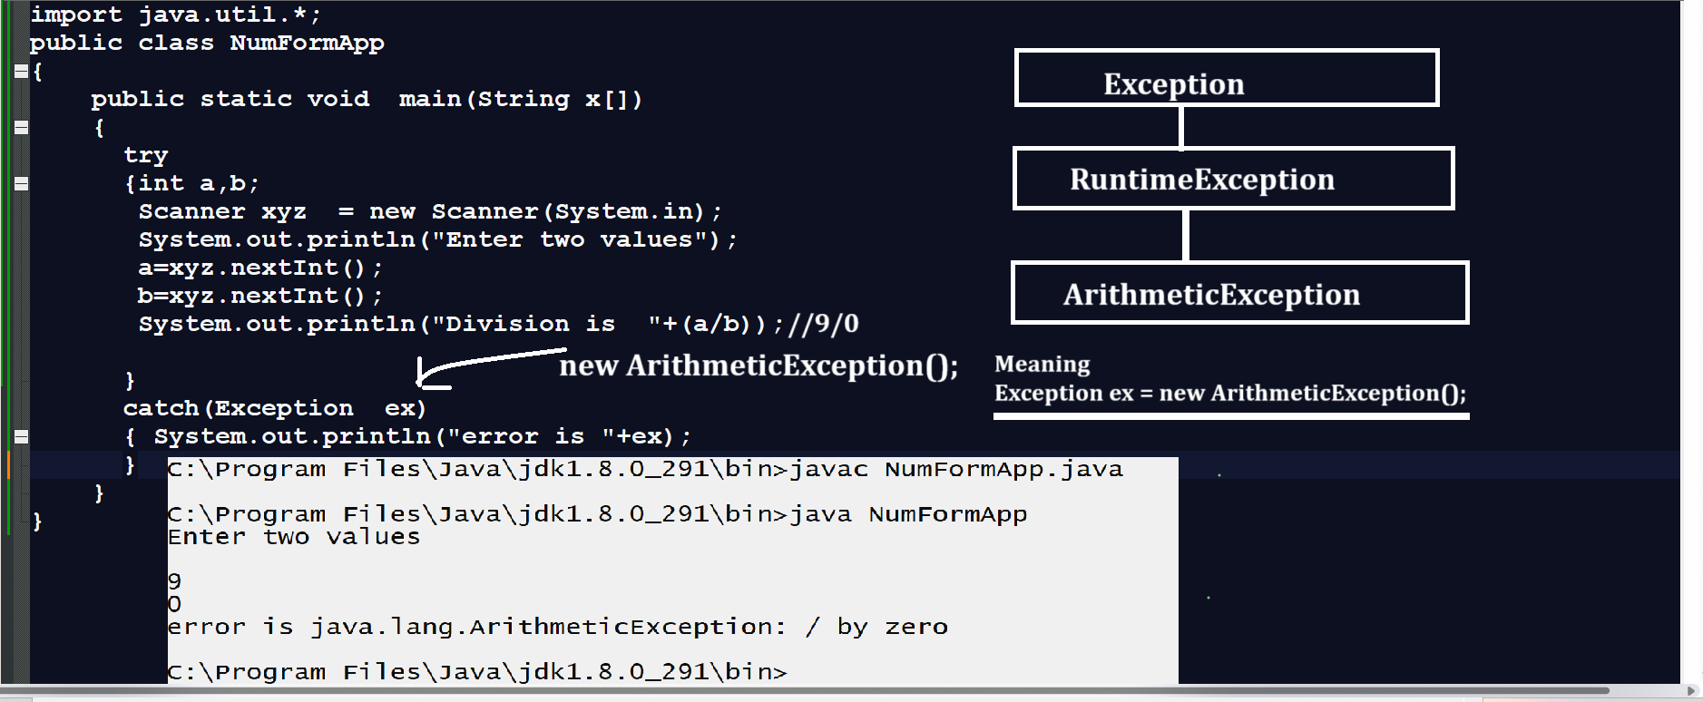

finally block: finally block can execute always if exception generate in code or not Means we can say normally finally recommend to execute code in any situation like as database connection close , file connection close etc
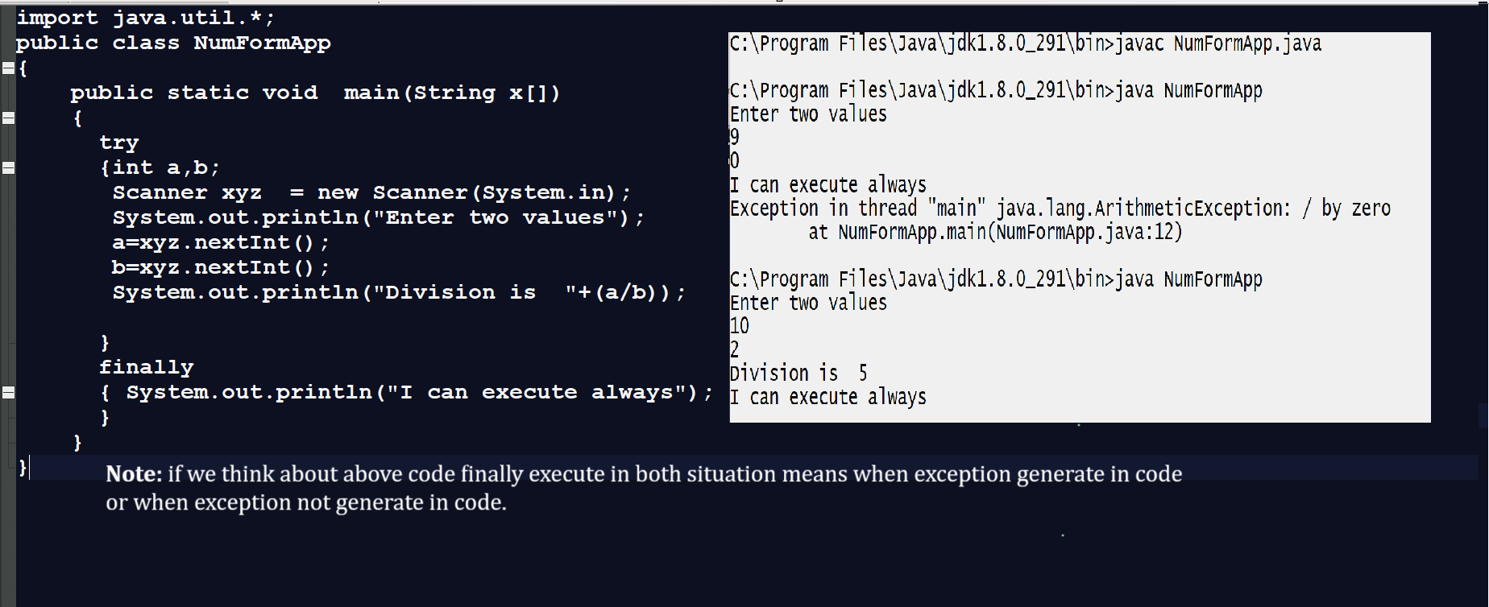

Note: when we use try catch and finally then catch execute after that finally executed if exception occur means when we write catch with try block then JVM handle exception first and after that execute finally block.
import java.util.*;
public class NumFormApp
{ public static void main(String x[])
{try
{int a,b;
Scanner xyz = new Scanner(System.in);
System.out.println("Enter two values");
a=xyz.nextInt();
b=xyz.nextInt();
System.out.println("Division is "+(a/b));

}
catch(Exception ex)
{ System.out.println("Error is "+ex);
}
finally
{ System.out.println("I can execute always");
}
}
}
Output
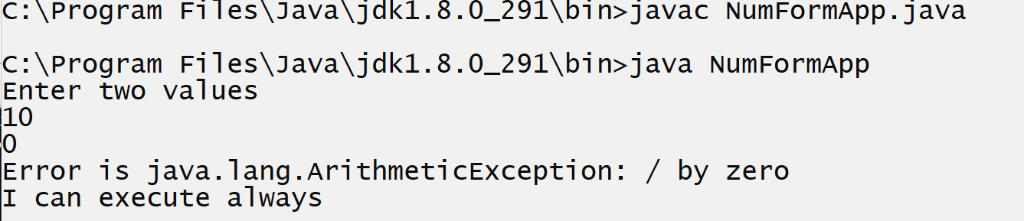

throws clause in exception handling
______________________________________________________________________________
throws is a clause in exception handling which is used for manage the checked exception means when you want to handle the checked exception with function then throws clause can use means if we use the throws clause with function definition then we not need to write try and catch within function definition we need to write try and catch at function calling point.
Syntax of throws clause
_______________________________________________________________________
return type function name(datatype size)throws exception type {
write here your logics
}
}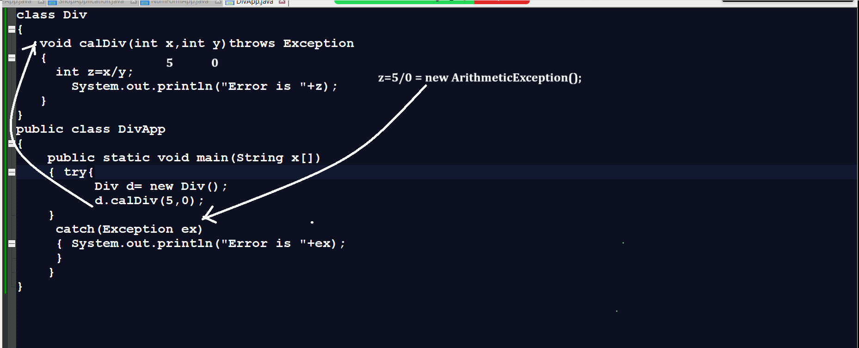
throw
_______________________________________________________________________
throw keyword is used for handle the user defined exception in JAVA

Q. What is user defined exception?
________________________________________________________________________
User defined exception in java means those exception classes define by user called as user defined exceptions

Q. Why we need to declare user define exceptions?
_______________________________________________________________________________
1. When user want to create exception or generate error message according to his project
Requirement then we required to create user defined exception
2. If Developer has some error or exception at program run time and java not provide exception handling class to us then user can create own exception class and handle the exception or error

How to create user defined exception in JAVA
_________________________________________________________________________
If we want to create user defined class in java we have to use following syntax
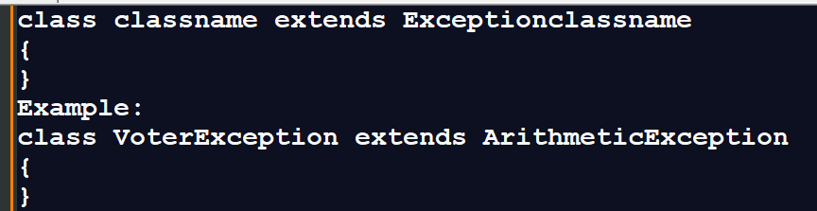

Example: Suppose consider we are working voting application and if voter age is less than 18
then throw the user defined message Your are not eligible means you can create user defined exceptions for voting application.
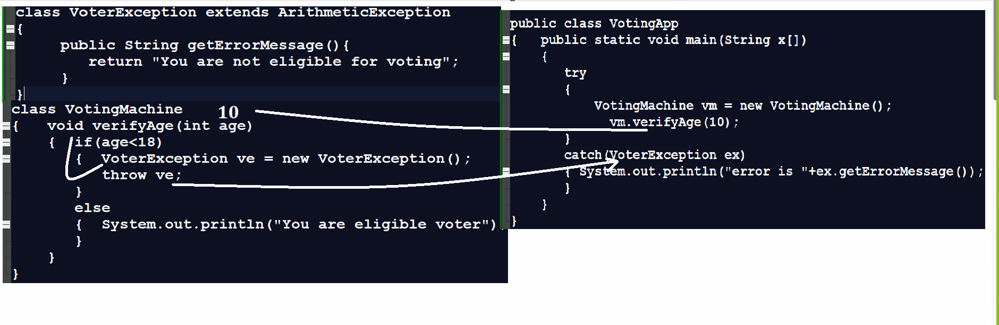

Note: if we use throw then we need to create object of user defined class and throw it and when we use throw then we not need to write try and catch in function definition we required to write try and catch at function calling point.

Q. What is difference between throw and throws?
__________________________________________________________________________
Throw | Throws
Throw is used for handle the user defined exception | Throws is used for handle checked exceptions
Throw need to create manual object using new keyword | Throws not need to create manual object internally it is created by JVM
Throws can work with single exception object at time | Throws can work multiple objects at program run time

